### **Chapter 3: Responsible Driving**

### **Responsible Driving**

Safe driving requires a commitment to responsible behavior on the road. This includes controlling your speed, avoiding dangerous activities like street racing, and respecting traffic laws. By being a responsible driver, you contribute to safer roads for everyone.

**Florida Crash Data — 2024 Highlights**

**Impaired Driving (Alcohol & Drugs)**

* 4,025 alcohol-only crashes, resulting in 145 deaths and 2,318 injuries (FLHSMV, 2025).
* 249 drug-only impairment crashes and 141 involving both alcohol and drugs (FLHSMV, 2025).
* In total, about 6,000 impaired-driving crashes occurred, causing roughly 900 fatalities (FLHSMV, 2025).

**Distracted Driving**

More than 103,500 crashes involved distraction, including nearly 300 deaths and over 2,200 serious injuries (FLHSMV, 2025).

**Speeding**

Florida consistently sees 24,500+ crashes each year tied to speeding, resulting in hundreds of deaths and thousands of injuries (Andrew Pickett Law, 2024).

**Aggressive Driving**

Although 2024 data is still being processed, previous records show 10,699 aggressive-driving crashes in 2020, with 80 deaths and 5,048 injuries—and recent trends indicate that pattern continues (Andrew Pickett Law, 2024; FLHSMV, 2025).

**What These Numbers Mean**

Each behavior—whether impairment, distraction, speeding, or aggression—poses real danger. Many of these happen together in a single crash. Seeing the scope of these issues underscores why responsible driving isn’t optional—it’s essential for protecting lives.

#### **The Risks and Consequences of Speeding**

#### Speeding remains one of the most frequent and dangerous forms of reckless driving. It dramatically increases the likelihood of crashes, injuries, and deaths. In this section, we’ll explore the specific dangers of speeding and highlight the legal and financial consequences.



#### **Why Speeding Is So Dangerous**

#### Reduced vehicle control: As speed increases, it becomes more difficult to safely steer through curves, avoid obstacles, and maintain control—especially in poor weather or unfamiliar areas.

#### Longer stopping distances: A vehicle traveling at higher speeds takes significantly more distance to come to a complete stop, increasing the risk of rear-end collisions and fatal collisions.

#### Decreased reaction time: Speeding reduces the time available to react to sudden hazards like pedestrians, other vehicles, or changes in traffic flow.

#### **Speed and Crash Severity**

#### Speeding not only makes crashes more likely, but it also increases the force of impact, making injuries and fatalities far more severe.

#### **Reduce Your Speed**

Slowing down while driving is one of the simplest yet most effective ways to improve road safety. It allows you to process information more effectively, make better decisions, and avoid dangerous situations.

At 60 miles per hour, your vehicle covers about 88 feet every second—that's 5,280 feet per minute. If an unexpected hazard appears on the road, your car will likely travel over 130 feet before you even begin to apply the brakes. Add an average human reaction time of 1.5 seconds, and your car can travel another 130+ feet, effectively doubling the total stopping distance. That extra space could mean the difference between a near miss and a devastating collision—with a child, another vehicle, or a roadside obstacle.

Thanks to advancements in braking systems and tire technology, modern vehicles can stop more efficiently than ever. However, physics hasn’t changed: no matter how advanced your car is, speed multiplies the force involved in a crash.

Here’s a crucial point: when you double your speed—say, from 30 mph to 60 mph—your stopping distance doesn’t just double; it quadruples. That’s because your vehicle’s kinetic energy increases by four times when your speed doubles, making it much harder to stop in time.

Although stopping distances vary between vehicles due to factors like weight, tires, and road conditions, the greatest variable is human reaction time. Most drivers don’t react in under half a second; the typical response time ranges from two-thirds of a second to a full second in normal conditions.

Even more concerning, younger drivers, who are often assumed to have quicker reflexes, are statistically more likely to freeze up when faced with an unexpected danger—sometimes taking over two seconds to respond. This delay drastically increases the risk of a crash.

Here are four key reasons to slow down:

**Increased Awareness** – Click To See Why: Driving at a reduced speed lets you notice more details about your surroundings, such as road signs, pedestrians, or unexpected hazards.

**Better Decision-Making** – Click To See Why: With more time to assess and analyze road conditions, you can predict potential risks and plan accordingly.

**Improved Reaction Time** – Click To See Why: Slower speeds provide you with more time to react to sudden changes, such as a pedestrian crossing or a car braking unexpectedly.

**Time for Others to React** – Click To See Why: By driving at a safe speed, you also give other drivers more time to respond to your movements, reducing the risk of collisions.

#### **Latest Crash Data and Findings**

#### In 2023, speeding contributed to 29% of all traffic fatalities, accounting for 11,775 deaths in the United States (NHTSA, 2023).

#### In 2023, speeding was involved in 37% of fatal crashes for male drivers aged 15–20 and 33% for male drivers aged 21–24—both the highest proportions among driver age and sex groups (NHTSA, 2024)

#### According to the AAA Foundation for Traffic Safety, the risk of a fatal crash doubles for every 10 mph increase over 50 mph (AAA Foundation, 2022).

#### In 2023, approximately 41% of all traffic fatalities occurred on rural roads—where higher speed limits and other factors continue to contribute to a disproportionate share of speed-related deaths (NHTSA/I‑I‑H‑S data)

#### In pedestrian deaths, speeding remains a key factor: it is involved in about 1 in 3 pedestrian fatalities, according to the Governors Highway Safety Association (GHSA, 2023).

According to NHTSA, **speeding-related crashes**, including those from reckless driving, resulted in **11,775 fatalities in 2023**, representing **29% of all traffic fatalities**

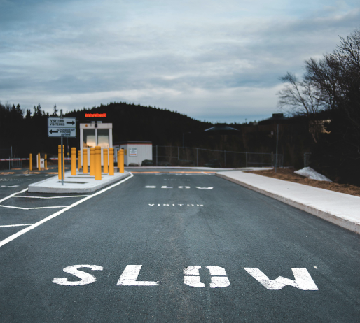

#### **Legal and Financial Consequences of Speeding in Florida**

#### Fines and Court Penalties

#### Speeding fines in Florida increase based on how far over the limit you were driving:

#### 6–9 mph over limit: ~$144

#### 10–14 mph over: ~$219

#### 15–19 mph over: ~$269

#### 20–29 mph over: ~$294

#### 30+ mph over: Requires a mandatory court appearance, with possible reckless driving charges and fines starting at $369

#### 50+ mph over: Fine is $1,000 for the first offense, $2,500 for the second, and includes license suspension (Florida DHSMV, 2024)

#### **Driver License Points System**

#### Speeding also adds points to your driving record:

#### 3 points for driving up to 15 mph over the limit

#### 4 points for 16+ mph over

#### 6 points if speeding results in a crash

#### Additional 3 points if you were texting and caused a crash

#### Accumulating 12 points in 12 months results in a 30-day license suspension. For drivers under 18, 6 points in 12 months triggers a license restriction (Florida DHSMV, 2024).

#### To restore driving privileges after suspension, drivers must complete a 12-hour Advanced Driver Improvement course.

#### **Increased Insurance Premiums**

#### Speeding violations also have long-term financial consequences:

#### In Florida, the average insurance premium increase after a speeding ticket is about $586 per year (Bankrate, 2024).

#### On average:

#### Post-ticket premium for women: $3,774/year

#### Post-ticket premium for men: $3,764/year

#### (Bankrate, 2024)

#### For serious speeding or repeat violations, the increase can exceed $700 per year, and may even result in policy cancellation or denial of coverage.

Remember, speed limits are there for a reason—they are calculated based on the safest possible speed for specific road conditions. Adjust your speed according to weather, traffic, and visibility.

As you drive, ask yourself: Is this risk worth taking? Every time you drive, remind yourself that driving is a responsibility, and defensive driving minimizes your risks and helps keep you and others safe.

#### **Street Racing and Reckless Driving**

Engaging in dangerous activities such as drag racing, street takeovers, or stunt driving poses a severe risk to public safety and carries significant legal consequences.

**Understanding Reckless Driving:**

Reckless driving is a serious offense that poses significant risks to yourself and others on the road. In this section, we will explore the legal aspects and consequences associated with reckless driving. Understanding these consequences is essential for promoting responsible driving behavior and ensuring the safety of all road users.

##### **Florida Statutes on Street Racing (FS 316.191,2)**

* **Definition**: The term "coordinated street takeover" refers to an event where multiple drivers obstruct traffic to perform dangerous activities such as racing or stunt driving.
* **Penalties**:
  + Increased fines for violations, including drag racing, street takeovers, stunt driving, contests, or exhibitions.
  + Enhanced criminal penalties for repeat offenders.
  + Specific penalties for those who knowingly obstruct or interfere with emergency vehicles responding to an emergency during such activities.
  + Arresting officers are authorized to seize vehicles involved in these acts, and the Florida Highway Safety and Motor Vehicles (FLHSMV) may revoke the offender's driver license for a set period.
* **Spectator Penalties**: Spectators at illegal races or street takeovers may also face fines, emphasizing that such activities are not only dangerous for participants but for anyone encouraging or supporting them.
* **Vehicle Impoundment**: Law enforcement officers can impound vehicles involved in these activities at the time of arrest, ensuring they are removed from the roads immediately.

In Florida, speeding and aggressive driving—including reckless behavior and illegal street racing—were contributing factors in **16,092 traffic events** in 2023. These incidents led to **296 fatalities** and **2,519 incapacitating injuries**, highlighting a significant increase from the previous year's figures (FLHSMV, 2023). The data underscores the growing concern over dangerous driving behaviors on Florida's roadways.

**Fleeing from Law Enforcement**

Fleeing from a law enforcement officer in a motor vehicle is automatically classified as **reckless driving** under Florida law. This action poses an extreme danger to public safety and carries **serious legal consequences**.

**Penalties for Reckless Driving**

The penalties for reckless driving depend on the number of previous offenses:

* **First offense**: May result in **up to 90 days in jail**, a **fine between $25 and $500**, or both.
* **Second or subsequent offenses**: May lead to **up to 6 months in jail**, a **fine between $50 and $1,000**, or both.

**When Reckless Driving Causes Damage or Injury**

If reckless driving leads to damage or harm, the consequences increase:

* **Causing damage to property or minor injury to another person** is classified as a **first-degree misdemeanor**, punishable under **Sections 775.082 or 775.083**.
* **Causing serious bodily injury**—defined as an injury that poses a significant risk of death, causes permanent disfigurement, or results in long-term loss of bodily function—is a **third-degree felony**, punishable under **Sections 775.082, 775.083, or 775.084**.

**Additional Fine for Emergency Medical Services**

In addition to other fines or penalties, a **mandatory $5 fee** is added to reckless driving convictions. This amount is forwarded to the **Florida Department of Revenue** and deposited into the **Emergency Medical Services Trust Fund** to support statewide emergency care services.

**Reckless Driving Involving Alcohol or Controlled Substances – Additional Penalties**

If a person is convicted of **reckless driving**, and the violation involved **alcohol, certain chemical substances, or controlled substances**, additional penalties may apply. In such cases, the **court may require** the individual to **complete a DUI program substance abuse education course and undergo an evaluation**, as outlined in **Section 316.193(5), Florida Statutes**.

It is important to understand that **failure to report for, complete, or comply with the course, evaluation, or any recommended treatment** will result in the **cancellation of the individual's driving privilege**.

Driving privileges may only be **reinstated upon successful completion** of the required program and **verification** from the DUI program provider.

This process ensures that individuals who engage in substance-related reckless driving receive appropriate intervention and education to reduce the risk of future offenses and improve roadway safety.

#### **Why Responsible Driving Matters**

Driving responsibly isn't just about following laws—it's about valuing your life and the lives of others. Speeding, reckless behavior, and street racing can have devastating consequences, including severe injuries, loss of life, and significant legal and financial penalties. By practicing responsible driving, you:

* Reduce the risk of collisions.
* Promote a culture of safety on the road.
* Avoid costly fines, legal trouble, and the possibility of losing your license.

Be mindful, respect the rules, and make decisions that prioritize safety over recklessness. Roads are shared spaces, and responsible driving ensures that everyone arrives at their destination safely.

### **Alcohol and Drugs: Driving Under the Influence (DUI)**

Driving under the influence (DUI) is one of the most dangerous and preventable causes of crashes on Florida’s roads. It poses serious risks to the driver, passengers, and everyone else on the road. Impaired driving affects physical coordination, mental judgment, and emotional stability—essential components of safe driving.

#### **Florida DUI Statistics**

* In 2023, there were **12,429 fatalities nationwide** due to alcohol-impaired driving crashes, representing approximately **30% of all traffic-related deaths** (NHTSA, 2023). In Florida, **alcohol-confirmed crashes** accounted for **363 fatalities and 3,104 injuries**, based on a total of **5,132 crashes** involving alcohol (FLHSMV, 2023).
* Nationally, an alcohol-related death occurs every 45 minutes, and almost 30% of traffic fatalities involve alcohol (NHTSA, 2023).
* In Florida, alcohol-impaired crashes contributed to over 33% of fatal crashes in 2024, higher than the national average (FLHSMV, 2025).

#### **Alcohol as a Drug**

Alcohol is a drug with varying effects based on consumption level. Even small amounts impair reaction time and judgment. Drinking and driving do not mix at any level, and the dangers escalate as Blood Alcohol Content (BAC) rises.

**Effects of Alcohol on Driving**:

* + **Impaired Vision**: Alcohol reduces peripheral vision and depth perception, making it harder to see pedestrians, merging traffic, or parked vehicles.
  + **Slower Reaction Times**: Drivers are less able to react to emergencies or changes in traffic.
  + **Poor Judgment**: Alcohol increases the likelihood of risky behaviors and reduces decision-making ability.

Alcohol relaxes the muscles that control your eyes, making it harder to adjust to sudden changes in light—like the glare from oncoming headlights. According to the National Institutes of Health, it usually takes between 7 seconds and 7 minutes for eyes to recover from glare. At 55 miles per hour, that delay could mean traveling the distance of two or more football fields. For drivers who have been drinking, the recovery time is even longer.

Drinking also impairs your peripheral vision, making it harder to notice vehicles merging, passing, or parked along the roadside. In addition, alcohol reduces your depth perception, making it more difficult to judge distances between your vehicle and others.

### **Effects of Alcohol on the Body & Brain**

#### **Physical Impairments**

#### **Muscle Coordination**: Alcohol diminishes muscle control, affecting your ability to walk, speak, and perform tasks requiring precision.

#### **Vision**: Alcohol relaxes eye muscles, reducing the ability to recover from glare, such as headlights, which typically takes 7 seconds to 7 minutes under normal conditions. Drunk drivers take significantly longer.

#### **Peripheral Awareness**: Alcohol reduces your ability to detect objects or vehicles on the sides while focusing straight ahead, increasing the risk of collisions.

* **Glare Recovery**: Alcohol slows the ability to adjust to sudden light changes, such as oncoming headlights.

#### **Distance Judgment**: Alcohol decreases depth perception, making it harder to judge the distance of other cars or objects.

#### Once absorbed, alcohol affects both the body and the brain, impairing cognitive and physical functions essential for safe driving.

#### **Mental Impairments**

#### Alcohol slows reaction time and impairs decision-making abilities, leading to reckless behavior and poor judgment.

#### It diminishes analytical thinking, leading to reactive and often illogical behavior, described as "unreality," where individuals cannot accurately gauge the consequences of their actions.

If you drink alcohol in the future, note its effects on your mind and body, and consider how driving skills are severely impacted by alcohol.



**Alcohol Absorption into the Bloodstream**

#### Alcohol affects the body differently from food because it is absorbed directly into the bloodstream through the stomach lining. This rapid absorption leads to quick and powerful effects. Several factors influence how alcohol affects an individual, including time, body weight, and stomach contents.

The relationship between alcohol consumption and BAC is linear: the more alcohol consumed, the higher the BAC. Impairment begins before the legal limit of 0.08%, with effects like reduced judgment and slower reaction times noticeable at lower levels (e.g., 0.02%). A standard drink—whether 12 oz of beer, 5 oz of wine, or 1.5 oz of spirits—contains roughly the same amount of alcohol and affects BAC similarly.

#### **Time**

#### The body typically processes one ounce of alcohol per hour. However, factors like physical activity can influence the rate of alcohol metabolism.

#### Contrary to popular belief, exercising to "sober up" does not help and can make you feel worse.

#### **Body Weight**

#### Alcohol tolerance varies based on body mass and blood volume.

#### Generally, individuals with smaller body masses become intoxicated faster because their bodies process alcohol differently.

#### **Stomach Contents**

#### Food in the stomach delays alcohol absorption but does not prevent it. Drinking on an empty stomach leads to faster intoxication, while a full stomach slows the process. Regardless, alcohol impairs driving abilities in all scenarios.

The effect of alcohol consumption on BAC depends on factors like body weight, sex, and drinking rate, but generally, a **standard drink** (12 oz beer, 5 oz wine, or 1.5 oz spirits) increases BAC by approximately **0.02%**. After one drink, BAC rises, and impairment begins, even before reaching the legal limit of 0.08%. For example:

* **0.02% BAC** – Click To See The Effect: Mild relaxation and slight impairment in judgment.
* **0.05% BAC** – Click To See The Effect: Noticeable impairment in coordination and reaction time.
* **0.08% BAC** – Click To See The Effect: Legal intoxication with significant impairment in driving abilities.

Each additional drink increases BAC and intensifies impairment, with alcohol metabolized at about 0.015% per hour. Understanding alcohol metabolism is key for identifying when driving is unsafe and reflecting on past behaviors.

Some myths about drinking alcohol say that taking cold showers, drinking black coffee, or exercising will sober a person up. This is not true. Only time, body weight, the number of drinks, and how much has been eaten can determine how long it takes anyone to sober up.

It usually takes one hour for the body to get rid of one drink. If a person drinks more than one drink an hour, one hour of sobering up time should be allowed for each extra drink before they consider driving.

#### **BAC Levels and Driving Impairment**

Below is a breakdown of Blood Alcohol Content (BAC) levels and their effects on driving:

| **BAC** | **Effect on Driving** |
| --- | --- |
| 0.01–0.04 | Reduced visual tracking and multitasking abilities. |
| 0.05–0.07 | Decreased coordination and steering capability. |
| 0.08–0.09 | Impaired memory, concentration, and speed control. |
| 0.10–0.14 | Difficulty maintaining lane position and braking effectively. |
| 0.15+ | Severe loss of vehicle control and critical thinking abilities. |

Drivers with BAC levels from 0.01 to 0.07 were linked to over 2,100 fatalities in 2023—below the legal limit, yet deadly (NHTSA, 2023). It is unlawful for anyone under 21 years of age to drive with ANY detectable amount of alcohol in their system in Florida.

Have you ever driven after drinking—thinking you were “just buzzed” or that you could make it home safely? It’s a question worth asking, not to shame, but to reflect. DUI has caused many drivers, perhaps including you, financial, emotional, physical, and life-threatening problems, and DUI will continue to negatively impact lives until all drivers make a commitment against it. Many people underestimate how even small amounts of alcohol can impair reaction time, judgment, and coordination. These split-second differences can—and often do—mean the difference between life and death.

### **Scenario: “I Only Had Two”**

#### It’s Friday night, and Jason, 26, meets up with friends at a bar after work. He’s had a long week and tells himself he deserves to unwind. He drinks two strong cocktails over the course of an hour and feels “fine”—a little warm, but alert. He laughs off his friend’s offer to call a rideshare. “I’m good. I’ve driven after more than this,” he says.

#### On the way home, Jason doesn’t see the stop sign in time. He slams on the brakes, but it’s too late. His car clips another vehicle in the intersection. The other driver, a 35-year-old mother picking up her child from a sleepover, suffers a traumatic brain injury. Jason’s BAC is 0.06—under the legal limit in Florida, but law enforcement still arrests him for **DUI with injury** due to his impairment behind the wheel.

#### Jason now faces a suspended license, court fines, legal fees, and mandatory DUI education. But the real weight is emotional: the knowledge that someone else's life was permanently changed because he thought he was “okay to drive.”

After reflecting on Jason’s experience, it’s important to ask: What should he have done differently? And more importantly, How can you apply that insight to your own choices—both in theory and in real life?

Consider these scenarios:

* You're at a party and have had a couple of drinks. Do you get behind the wheel or call a ride? Provide a safe course of action in this scenario.
* You notice a friend trying to drive after drinking. Do you intervene or stay silent?

These simulations challenge you to confront risky thinking before you're actually in danger, giving you the tools to act differently next time.

In **real-life situations**, the goal is to turn those new attitudes into habits. That might mean setting a plan in advance whenever alcohol is involved—designating a sober driver, using a rideshare app, or deciding never to mix drinking and driving, even “just a little.”

Changing driver behavior isn’t just about knowing the law—it’s about practicing better decision-making in both simulated and real scenarios until safety becomes second nature. That’s how lives are saved.

**What You Can Do Now**

Reflect on any past moments when you drove after drinking—even just a little.

Plan who will drive before drinking starts.

Own it — recognize how even low BAC levels can impair you.

Share this with friends or family; awareness spreads safety.

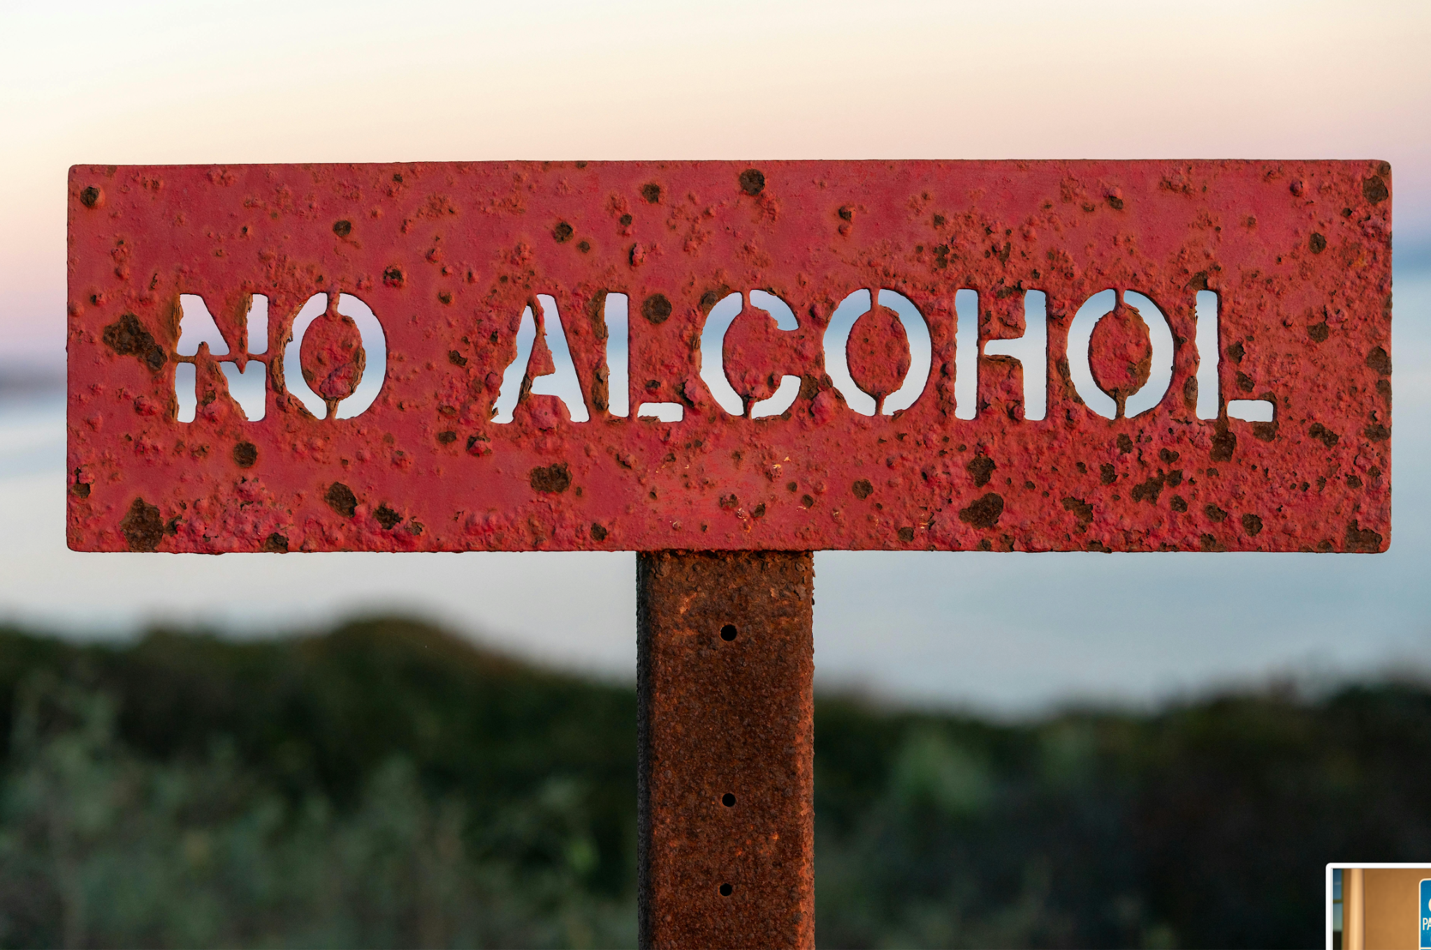

### **Drugs and Driving**

Driving under the influence of drugs—whether prescribed, over-the-counter, or illegal—can impair your ability to operate a vehicle safely. Florida law recognizes that impaired driving extends beyond alcohol to any chemical or controlled substance that affects a driver's faculties, as outlined in **FS 316.193**. This statute explicitly prohibits driving under the influence of any substance listed in **statute 877.111**, including prescription medications and illegal drugs.

#### **Prescription and Over-the-Counter Medications**

Even legally prescribed medications or over-the-counter drugs can impair your ability to drive. Perhaps you or someone you know has caused a traffic collision, unknowingly affected by medications. Learning how medications can affect you will help you have better driving habits in the future:

* **Drowsiness or Fatigue:** Medications for colds, allergies, or anxiety can make you sleepy, reducing reaction time and alertness.
* **Slowed Reflexes:** Some drugs impair your ability to respond to emergencies or sudden changes in traffic conditions.
* **Impaired Vision and Focus:** Certain medications, like diet pills, may initially make you more alert but later impair focus and vision.

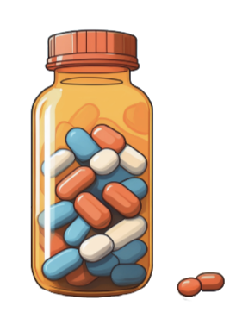

**Important Tips for Medication Use:**

* Always read labels carefully and follow usage instructions.
* Consult your doctor or pharmacist about potential side effects that could impair your ability to drive.
* Never take someone else’s medication
* Avoid mixing medications without medical advice.
* Never combine drugs with alcohol, as this can amplify impairment.

#### **Illegal Drugs**

Illegal drugs, including marijuana, amphetamines, cocaine, and barbiturates, can significantly impair driving abilities:

* **Marijuana:** Affects spatial judgment, reaction time, and focus, making it difficult to monitor multiple driving tasks.
* **Stimulants (e.g., cocaine, amphetamines):** May cause erratic driving behavior by initially increasing alertness but later impairing focus and coordination.
* **Depressants:** Reduce motor control, reaction time, and overall awareness.

Under Florida law, driving under the influence of any impairing substance is illegal. If an officer suspects drug use, they may require a blood or urine test. Refusal to comply is a separate offense that can result in license suspension and other penalties.

#### **Medications and Alcohol**

Combining alcohol with certain medications can increase impairment risks. For example:

* Alcohol intensifies the sedative effects of drugs, worsening drowsiness and coordination issues.
* Narcotics, such as opiates, can quickly and severely impair motor skills and judgment when combined with alcohol.

To ensure safety:

* Test new medications on a day you do not need to drive to observe any effects.
* Understand that even if you feel okay, subtle impairments can still make driving dangerous.

#### **Narcotics and Their Effects**

Narcotics include substances like marijuana, LSD, amphetamines, cocaine, and opiates. These drugs can have rapid and significant effects on the body, impairing both physical coordination and cognitive function. Even small amounts can drastically reduce a driver’s ability to react appropriately to traffic conditions.

#### **Legal Consequences of Drug Impairment**

* Refusing a blood or urine test for suspected drug impairment can lead to license suspension and legal penalties, similar to refusing a Breathalyzer for alcohol testing.
* Possession of illegal drugs while driving can result in additional charges, including license suspension and criminal prosecution.

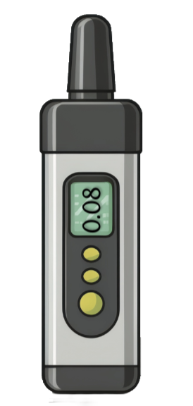

Driving under the influence of drugs, whether legal or illegal, is not only against the law but puts your life and others at risk. Stay informed, follow medical advice, and always prioritize safety on the road.

### **Intoxication and the Law**

Driving under the influence (DUI) is a serious offense with strict laws and severe consequences to ensure public safety. Below are key legal provisions and enforcement practices related to intoxication and impaired driving:

#### **Key Legal Provisions**

1. **Legal Drinking Age**:  
   The minimum drinking age across all 50 states, including Florida, is **21 years**.
2. **BAC Limit**:  
   In Florida and most states, a **Blood Alcohol Content (BAC)** level of **0.08** constitutes legal intoxication for drivers. For commercial drivers, the limit is **0.04 BAC**, and for individuals under 21, any detectable alcohol level (**0.02 BAC or higher**) is a violation.
3. **Sobriety Checkpoints**:  
   Many states, including Florida, utilize **sobriety checkpoints** to randomly test drivers for alcohol and drug impairment.
4. **Preliminary Breath Tests**:  
   About half of the states allow preliminary breath tests as evidence of intoxication.
5. **Restitution**:  
   In many states, DUI offenders must pay restitution for property damage or injuries caused, either directly to the victims or through a designated fund.
6. **Felony Vehicular Homicide**:  
   DUI drivers causing fatalities can face charges of **felony vehicular homicide**, treated as **murder** in most states.
7. **Refusal to Submit to BAC Testing**:  
   In Florida, refusal to take a BAC test leads to an automatic **license suspension**. It is also considered a **first-degree misdemeanor** under **Florida Statute 316.1939**.

### **DUI Penalties in Florida**

#### **Criminal Prosecution**

DUI offenders face prosecution in criminal courts and may be subject to:

* **Fines**: Monetary penalties determined by the severity of the offense.
* **Mandatory Counseling**: Enrollment in programs to address substance abuse.
* **Jail Time**: Imprisonment based on the nature and extent of the offense.
* **License Suspension or Revocation**: Temporary or permanent removal of driving privileges.

### **Florida DUI Enforcement Overview**

Florida implements stringent measures to monitor and penalize DUI offenders, including:

1. **Prior Offense Review**:  
   New license applicants are screened for prior DUI offenses in other states.
2. **Statewide Reporting System**:  
   Florida uses a centralized system to track DUI arrests, convictions, sanctions, and appeals.
3. **Vehicle Forfeiture**:  
   Vehicles driven by DUI offenders under a suspended or revoked license are subject to forfeiture.
4. **Mandatory Alcohol Evaluation**:  
   Convicted DUI offenders must undergo an **alcohol assessment** to determine the severity of their substance abuse issues.
5. **License Reinstatement**:  
   Non-compliance with mandatory programs disqualifies offenders from license reinstatement and may result in further legal action.

**DUI Felony Penalties (FS 316.1939)**: Offenders failing to comply with court-imposed programs or assessments face additional legal repercussions.

DUI laws are designed not only to penalize offenders but also to deter dangerous behavior on the roads. It is crucial for drivers to make safe and responsible choices to prevent DUI incidents and protect lives.

#### **First Offense Penalties (FS 322.271, FS 322.28)**

A DUI conviction in Florida carries significant consequences that remain on your driving record for **75 years**. No license will be reinstated until all penalties are satisfied and the offender completes a state-mandated rehabilitation or instructional program.

If convicted of driving under the influence (DUI) with a blood alcohol concentration (BAC) of **0.08 or higher**, or if your faculties are impaired by alcohol, drugs, or other controlled substances, the penalties include:

* **Fines**: $500 to $1,000.
* **License Revocation**: 180 days to one year.
* **Community Service**: Minimum of 50 hours.
* **Jail Time**: Up to 6 months.
* **DUI School**: Completion of a **12-hour program**.
* **Treatment Evaluation**: Required assessment to determine the need for substance abuse treatment.
* **Ignition Interlock Device**: Mandatory installation for up to **6 continuous months**.

#### **Second Offense (Within Five Years)**

* **Fines**: $1,000 to $2,000.
* **License Revocation**: 5 years, with eligibility for a hardship license after 1 year.
* **Jail Time**: 10 days to 9 months.
* **DUI School**: Completion of a **21-hour program**.
* **Ignition Interlock Device**: Up to **1 continuous year**.

#### **Third Offense (Within 10 Years)**

* **Classification**: Felony offense.
* **Fines**: $2,000 to $5,000.
* **License Revocation**: 10 years.
* **Jail Time**: 30 days to 12 months.
* **DUI School**: Completion of a **21-hour program**.
* **Ignition Interlock Device**: Mandatory installation for **2 continuous years**.

#### **Fourth Offense**

* **Classification**: Felony conviction.
* **Fines**: Minimum $2,000.
* **License Revocation**: Permanent, with no hardship reinstatement.
* **Jail Time**: Up to 5 years.

#### **Additional Consequences**

* If a DUI results in property damage, serious bodily injury, or death, penalties escalate significantly.
* For specific details, consult [Florida Statutes Chapter 316 Section 193](https://flsenate.gov).

#### **DUI Manslaughter or Murder**

* **Murder with a Motor Vehicle**:
  + Permanent license revocation with **no hardship reinstatement**.
  + Jail time and loss of certain civil rights, such as the right to vote.
* **DUI Manslaughter**:
  + Mandatory permanent license revocation.
  + Eligibility for hardship reinstatement after **five years**, provided the prison term is at least five years.

#### **Importance of Avoiding DUI**

DUI offenses can have lifelong impacts on your driving record, finances, personal freedoms, and relationships. Personally, costs include fines, legal fees, increased insurance premiums, DUI school, and possible ignition interlock installation, often totaling $10,000 or more (**Florida Statute §316.193**). Societally, alcohol-related crashes cost the U.S. over $58 billion annually, burdening healthcare, law enforcement, and judicial systems (**NHTSA, 2023**). Beyond legal consequences, these violations endanger lives, making it critical to never drive under the influence. These impacts emphasize the severe consequences of impaired driving.

### **CDLs and DUI**

For commercial vehicle drivers, the standards for blood alcohol concentration (BAC) are stricter than for regular drivers. Under **Florida law** and federal regulations:

* A BAC of **0.04 or higher** is considered legally intoxicated for a commercial driver.
* This applies whether the driver was operating a commercial vehicle or a personal vehicle at the time of the offense. Florida treats both situations equally.

#### **Consequences of DUI for CDL Holders**

1. **License Suspension:**Any conviction for driving under the influence (DUI) results in the suspension or revocation of a commercial driver’s license (CDL). This applies even if the DUI occurred in a personal vehicle.
2. **Loss of Livelihood:**A DUI conviction can lead to the permanent loss of a CDL, which directly affects the driver’s ability to work in the commercial driving industry.

#### **Heightened Responsibility**

Commercial drivers operate larger, heavier vehicles, often carrying passengers or hazardous materials. Because of the increased potential for harm, stricter BAC limits and penalties are enforced to ensure public safety.

CDL holders must exercise extreme caution and avoid any impairing substances to maintain their licenses and protect their careers.

### **The Implied Consent Law (FS 316.1932)**

The Florida Highway Safety and Motor Vehicles (FLHSMV) emphasizes that holding a driver’s or commercial driver’s license is a privilege—not a fundamental constitutional right. This privilege is granted by the state and can be revoked if laws are violated.

#### **Overview of the Law**

Under Florida’s **Implied Consent Law (FS 316.1932)**:

* By operating a motor vehicle in Florida, a driver automatically consents to submit to approved chemical or physical tests—such as breath, blood, or urine tests—if suspected of driving under the influence (DUI).
* These tests detect the presence of alcohol, drugs, or other chemical substances as outlined in **statute 877.111**.

#### **Penalties for Refusal**

* **First Refusal:** License suspension for 1 year.
* **Subsequent Refusals:** License suspension for 18 months and a **second-degree misdemeanor** charge.
* Drivers are informed that refusing a lawful test will result in suspension and may lead to additional penalties if it is a repeated offense.

#### **Special Circumstances**

* If a driver is **unconscious** and unable to refuse, law enforcement may still perform a blood test. The results can be used as evidence even if the driver objects later upon regaining consciousness.

#### **Protective Purpose of the Test**

Tests can help prove innocence if the driver is not legally intoxicated. A clean test result can demonstrate compliance with the law and avoid penalties associated with a refusal.

This law underlines the importance of accountability and safety for all road users, ensuring that impaired drivers face appropriate consequences while providing mechanisms to safeguard the rights of those who are not intoxicated.

#### **Zero Tolerance for Underage Drivers (**[**FS 322.2616**](https://flsenate.gov)**):**

The **Zero Tolerance Law** reflects Florida's firm stance against drunk driving for individuals of all ages, with stricter regulations for those under 21. This policy is designed to minimize alcohol-related incidents among young drivers by enforcing severe consequences.

Florida law explicitly prohibits anyone under 21 from purchasing, possessing, or consuming beer, wine, or hard liquor. Even a **single drink** may exceed the legal BAC limit for minors.

If a driver under 21 has a BAC of **0.02 or higher**, the following penalties apply:

1. **First Offense**:
   * Immediate **6-month license suspension**.
   * If the driver refuses testing, a **12-month suspension**.
2. **Second Offense**:
   * License suspension for **1 year**.
   * Refusal to submit to testing results in an **18-month suspension**.

#### **Activities Covered Under Zero Tolerance**

The law not only applies to motor vehicles but also extends to:

* **Off-highway vehicles**
* **Mopeds**
* **Motorcycles**
* **Boats**

#### **Consequences of Violation**

Young drivers found violating Zero Tolerance laws or refusing alcohol screening tests may face the following repercussions:

* **License Suspension**: Immediate loss of driving privileges.
* **Jail Time**: Mandatory overnight stay in some cases.
* **Legal and Financial Burdens**:
  + Court costs and legal fees.
  + Increased vehicle insurance rates.
* **Criminal Record**:
  + A DUI conviction in Florida remains on your record for **75 years**, severely impacting future opportunities, such as college applications and employment.

Finally, the last sobering thought is that over half of the young people killed in the alcohol related crashes mentioned above were not the ones who were drinking. Protect yourself and your future, and DON’T ride with anyone who has had a drink. You have way too much to lose.

### **Ignition Interlock Program in Florida**

*(FS 316.1937, FS 316.1938, FS 322.271)*

An ignition interlock is a device installed in vehicles to prevent drunk driving. It requires drivers to pass a breath alcohol test every time they start the vehicle. Additionally, the device may perform random tests while driving to ensure sobriety. If the test detects alcohol above the allowed limit, the car will emit loud warnings and may require the driver to stop.

#### **When Is It Required?**

The ignition interlock program applies to individuals arrested and convicted of DUI offenses after **July 1, 2002**, under the following conditions:

* **License Reinstatement**: For those eligible for a permanent or restricted driver's license.
* **Restricted Licenses**: Required for drivers applying for a license to drive for work or business purposes.

#### **How It Works**

* DUI convictions are electronically reported to the Florida Highway Safety and Motor Vehicles (FLHSMV).
* Court orders specify the suspension period and interlock requirements.
* A driver’s license is reissued with a "P" restriction, indicating the requirement for an ignition interlock device.
* The interlock period begins the day the "P" restriction is issued.

#### **Costs for Drivers**

* **Installation**: Approximately **$70**, plus tax.
* **Monthly Monitoring and Calibration**: Also around **$70 per month**, plus tax.
* **Refundable Deposit**: A deposit is required upon installation.
* For individuals unable to afford these costs, courts may allocate fines from violations to cover partial expenses. *(FS 316.1937 2d)*

#### **Device Specifications**

* Utilizes **fuel cell technology** for accurate alcohol detection.
* Prevents vehicle operation if the driver’s breath alcohol concentration is **0.025 or higher**.
* Equipped with a **rolling retest** feature for random alcohol testing while driving.
* All test results and data are recorded in a secure, web-based system accessible **24/7**.

The ignition interlock program is a critical component of Florida's DUI prevention strategy, aimed at reducing repeat offenses and enhancing public safety.

### **The Open Container Law (**[**FS 316.1936**](https://flsenate.gov)**)**

Florida is one of 36 states adhering to federal open container laws, which prohibit both the **possession** and **consumption** of alcoholic beverages in the passenger area of a motor vehicle. Here's what you need to know:

#### **Prohibited Actions**

* **Possession**: It is illegal to have an open container of alcohol in the passenger area of a vehicle, even if you are not consuming it.
* **Consumption**: Actively drinking from an open container while in the passenger area is strictly prohibited.

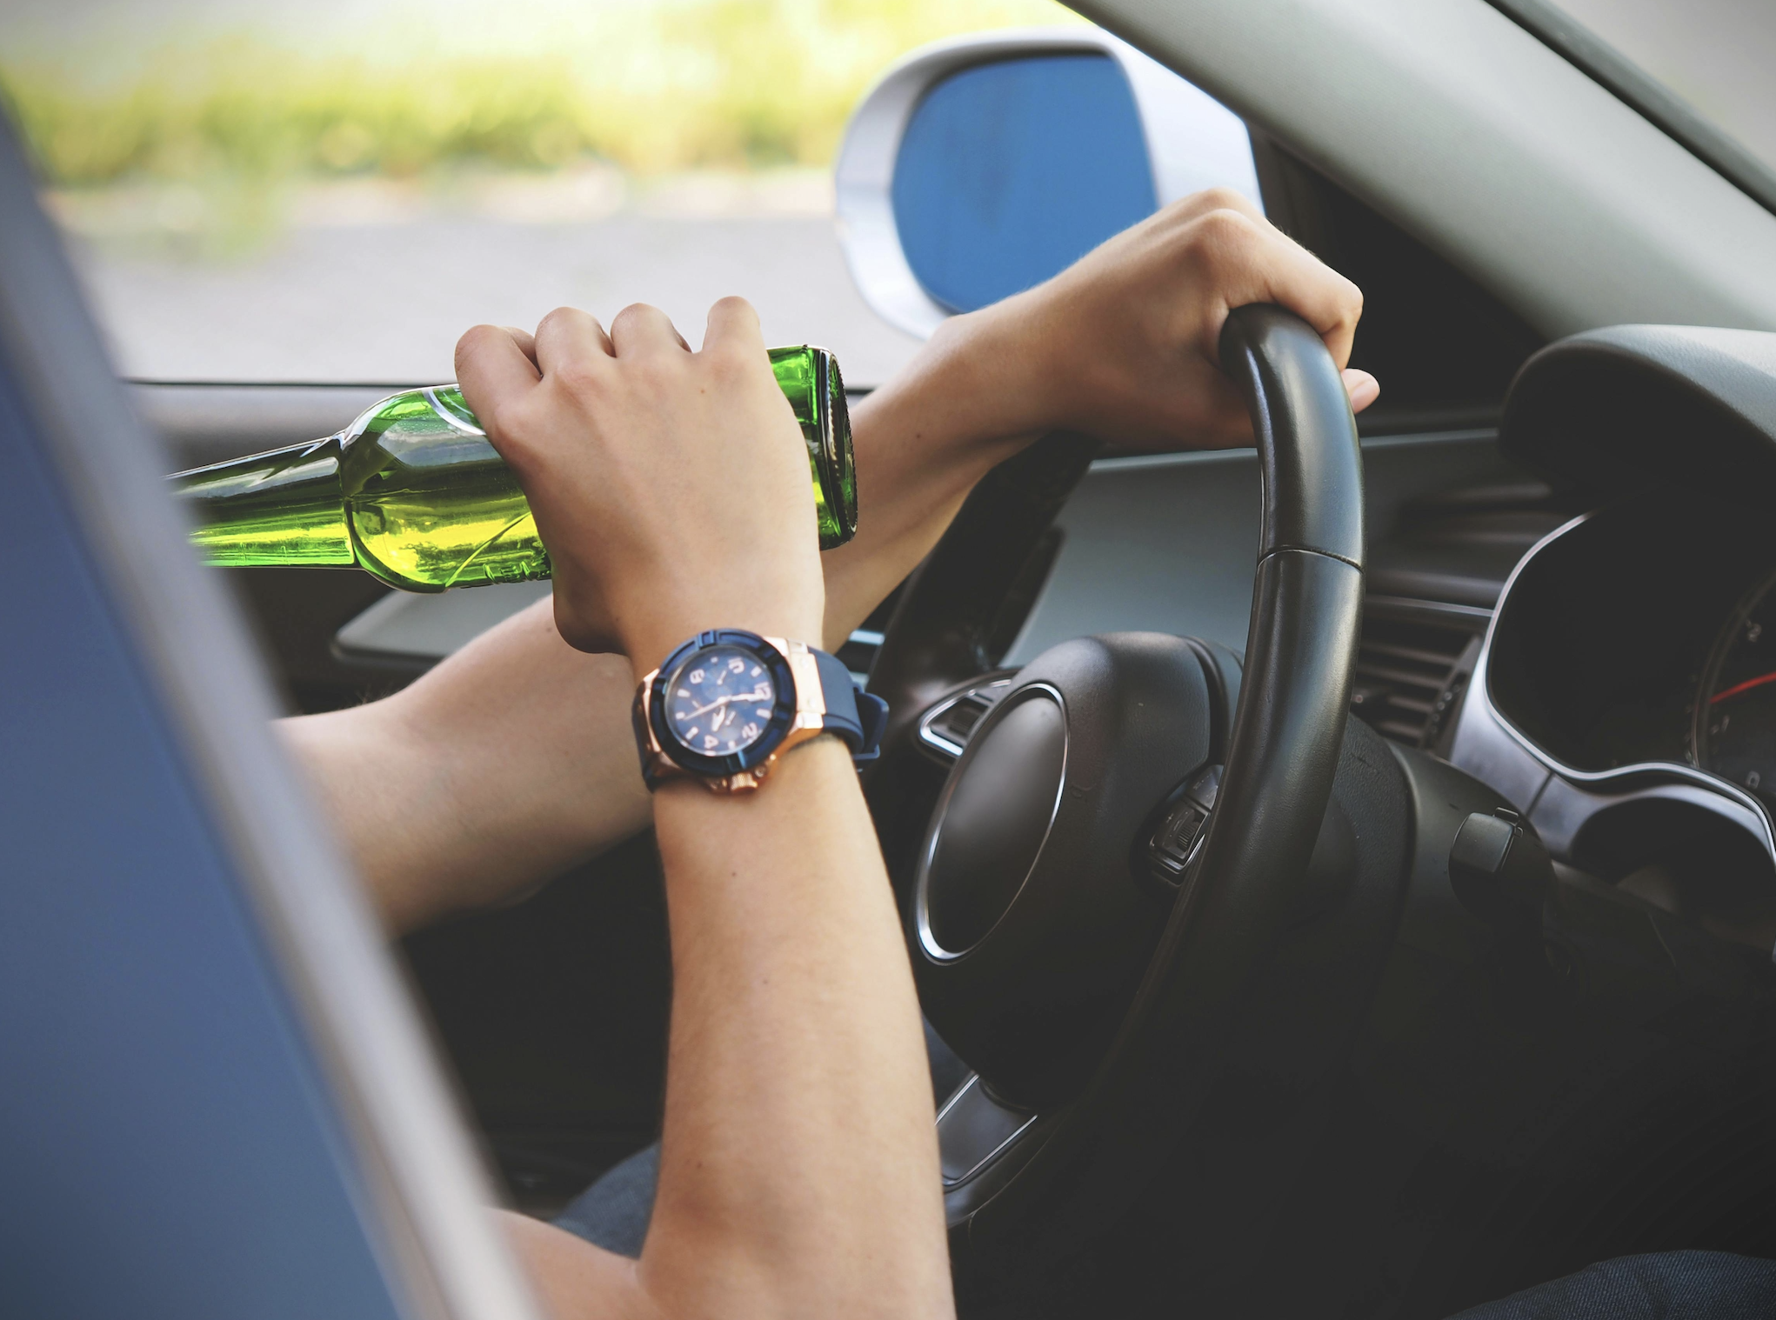

#### **Areas Covered**

The law includes all areas of a vehicle readily accessible to the driver or passengers, such as:

* The **passenger compartment** of a motor vehicle.
* **Unlocked glove compartments**.
* Other storage areas accessible from the seats.

#### **Primary Offense**

* This law is a **primary offense** in Florida, meaning law enforcement officers can stop and ticket a vehicle solely for violating the open container law, without requiring any other concurrent traffic violation.

#### **Key Takeaway**

To avoid violations, ensure that all alcoholic beverages are unopened and stored in the trunk or another area that is not accessible from the passenger compartment. This helps to comply with Florida's strict open container regulations and ensures the safety of everyone on the road.

### **Ways to Avoid Driving Impaired**

Driving under the influence (DUI) is a preventable risk that endangers lives. DUI prevention involves taking proactive steps to avoid operating a vehicle while impaired by alcohol or drugs. Florida offers several strategies and resources to promote responsible decision-making and prevent DUI incidents.

#### **Strategies to Prevent Impaired Driving:**

1. **Abstain from Alcohol or Drugs if Driving**If you plan to drive, it is essential to refrain from consuming any substance that could impair your ability to operate a vehicle safely.
2. **Use a Designated Driver**Select someone in your group to remain sober and take responsibility for driving. A designated driver ensures everyone in the group arrives home safely.
3. **Utilize Rideshare or Taxi Services**Platforms like Uber or Lyft, or traditional taxi services, provide convenient and safe alternatives to driving after consuming alcohol or drugs.
4. **Rely on Public Transportation**Use available public transit options such as buses or trains to travel without risking impairment-related driving.
5. **Call a Sober Friend or Family Member**If impaired, contact a friend or family member who is sober and able to pick you up and take you home.
6. **Stay Overnight**When attending an event involving alcohol or drugs, consider staying overnight at a friend’s home or a nearby hotel. This option ensures you are fully sober before driving again.

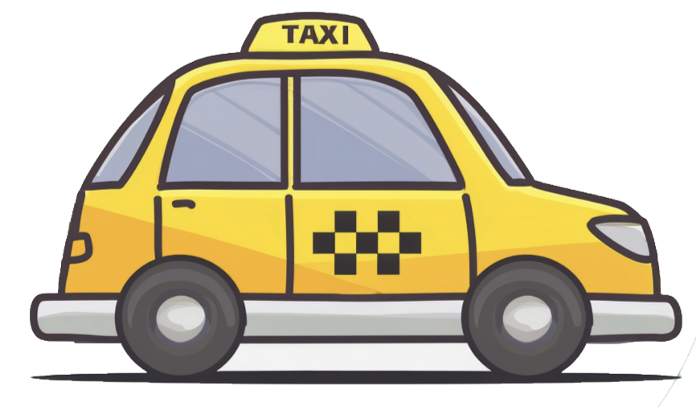

By incorporating these strategies, individuals can significantly reduce the risk of impaired driving and its consequences, promoting safety for themselves and others on the road.

### **The Designated Driver Program**

The National Designated Driver Program is an effective initiative aimed at reducing DUI incidents and promoting road safety. By preventing just one impaired driver from getting behind the wheel, the program helps ensure the safety of everyone on the road. Additionally, it alleviates peer pressure for those who want to participate in social gatherings without consuming alcohol.

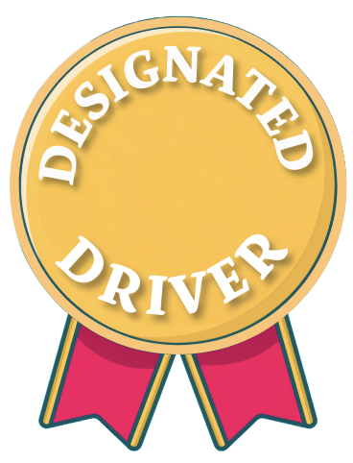

#### **Key Requirements for a Designated Driver:**

* **Valid Driver’s License:** The individual must hold a valid driver’s license.
* **Group Membership:** They must be part of a group of two or more people.
* **Identification as a Designated Driver:** The designated driver must clearly inform the server that they will abstain from drinking.
* **Abstinence from Alcohol:** They must not consume any alcoholic beverages during the outing.
* **Sobriety:** They must not be otherwise impaired by any substances.

#### **Benefits of Designated Driver Programs:**

* **Safety Assurance** – Click To Learn More: Designated drivers ensure their friends get home safely after an event.
* **Incentives** – Click To Learn More: Many restaurants and bars offer free non-alcoholic beverages as a token of appreciation for designated drivers.
* **Encouragement for Responsible Behavior** – Click To Learn More: Events or venues may offer discounts or perks to promote responsible drinking. If discounts are unavailable, ask for them, and favor establishments that support responsible behavior.

By adopting the role of a designated driver, individuals contribute significantly to DUI prevention and the overall safety of their communities.

### **Spotting Drunk Drivers**

Driving under the influence of alcohol or drugs is a significant danger to everyone on the road. Recognizing the signs of impaired driving can save lives, including your own. Law enforcement officers are trained to identify drunk drivers, but knowing what to watch for and how to respond can also help keep roads safer.

#### **Signs of Impaired Driving**

1. **Lane Drifting**A common sign of impaired driving is lane drifting. An intoxicated driver may struggle to maintain their position within a lane, weaving back and forth or crossing lane markings. This behavior indicates reduced motor control and poor judgment.
   * **What to Do**: Keep a safe distance from the vehicle and avoid attempting to overtake it. Note the car's license plate, color, and make if possible, and report the incident by calling *FHP (*347) or 911. Provide details about your location and the direction the vehicle is heading. Reporting such drivers is a responsible action that could prevent collisions.

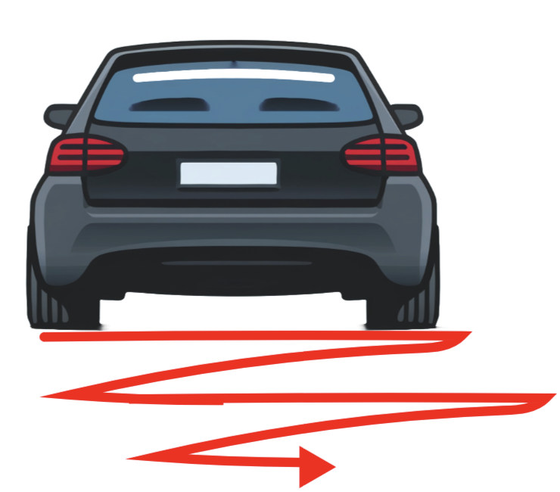

1. **Irregular Speed and Braking**Impaired drivers often fail to maintain consistent speeds. They may speed up or slow down unexpectedly or brake unnecessarily, even in normal traffic conditions. You might notice brake lights flashing erratically, indicating impaired judgment or delayed reactions.
   * **What to Do**: Keep a considerable distance to avoid sudden stops or collisions. If you suspect the driver is under the influence, report the vehicle to authorities with detailed information.
2. **Erratic Behavior**Drivers under the influence may exhibit unpredictable or irrational behavior, such as:
   * Making abrupt or incorrect turns (e.g., turning left instead of right).
   * Stopping or accelerating suddenly without reason.
   * Driving too close to the curb, the shoulder, or the centerline.
   * Ignoring traffic signals or signs, or hesitating at green lights.
   * Displaying overly cautious or overly reckless driving patterns.
   * **What to Do**: Stay alert and create a safe distance between your vehicle and theirs. If possible, change your route to avoid prolonged interaction with the impaired driver. Contact law enforcement immediately to report the behavior, sharing the vehicle description and location.

#### **Why Reporting Matters**

Reporting suspected drunk drivers isn't just a precaution—it's a lifesaving action. Impaired drivers are responsible for thousands of fatalities and injuries every year. By notifying the police, you are helping prevent potential harm to the driver, their passengers, and others on the road.

#### **Remember**

Never attempt to confront or stop a suspected impaired driver yourself, as this could endanger you and others. Instead, stay calm, observe from a safe distance, and allow law enforcement to handle the situation. Your quick actions could save lives and contribute to safer roads for everyone.

#### **Protect Yourself and Others**

* Never drink and drive.
* Report erratic driving by calling *FHP or 911.
* Educate yourself and others about the dangers of impaired driving.

For more information, visit the Florida Highway Safety and Motor Vehicles website ([FLHSMV.gov](https://www.flhsmv.gov))

### **Substance Abuse Education and Resources**

Substance abuse affects not only health and well-being, but also driving ability. Understanding available support is key to safe, responsible behavior behind the wheel.

#### **Getting Help: Florida Resources**

If you or someone you know is struggling with substance use, Florida offers a variety of local programs:

* **Florida DCF** – Connects individuals to treatment, counseling, and prevention services.  
   *(*[*www.myflfamilies.com/service-programs/substance-abuse/*](http://www.myflfamilies.com/service-programs/substance-abuse/)*)*
* **FADAA & FADAF** – Offer information on licensed treatment providers and recovery programs.  
   *(*[*www.fadaa.org*](http://www.fadaa.org) *|* [*www.fadaf.org*](http://www.fadaf.org)*)*
* **FARR** – Provides a directory of certified sober living homes.  
   *(farronline.org)*
* **Alcoholics Anonymous (AA)** and **Narcotics Anonymous (NA)** – Peer-based recovery meetings across Florida.  
   *(*[*www.aa.org*](http://www.aa.org) *|* [*www.floridana.org*](http://www.floridana.org)*)*
* **SAMHSA Helpline** – 1-800-662-HELP offers 24/7 free and confidential treatment referrals.

#### **Support Services in Florida**

Numerous services provide personalized care, including:

* **FACT Programs** – Community-based support for those with severe mental health or substance use disorders.
* **Recovery Peer Specialists** – Trained individuals in recovery helping others on their journey.
* **Crisis Intervention Teams (CIT)** – Trained law enforcement teams assisting in substance-related emergencies.
* **Florida Warm Line** – 24/7 peer support via phone for emotional or substance-related distress.
* **Counseling Centers & Support Groups** – Offer therapy, group support, and behavioral treatment statewide.

#### **Education & Awareness**

Prevention efforts include:

* **Public campaigns** and **school-based programs** on the dangers of impaired driving.
* **Community workshops** and **web resources** for learning about treatment and recovery.
* **Provider training** ensures healthcare professionals can spot signs of substance use and intervene early.

#### **Privacy and Confidentiality**

When seeking help:

* Your records are protected by **state law** and **HIPAA** (federal privacy law).
* Providers cannot share treatment information without your consent.
* Confidentiality agreements ensure a safe, non-judgmental environment for recovery.

#### **How to Get Referred**

Support can be accessed through:

* **Self-referral** – Contacting hotlines, treatment centers, or support groups directly.
* **Medical referral** – Healthcare professionals can guide you to appropriate care.
* **Law enforcement or community contacts** – Officers or trusted individuals can assist in connecting you to help.
* **Directories and helplines** – Offer current listings of treatment and support options.

**Remember:** Seeking help is a strong first step. Florida offers many tools and services to support recovery, protect your health, and keep roads safe. For updated, location-specific information, consult trusted directories, helplines, or a healthcare provider.

**3.5**

**Identifying Major Problems Created by Unsafe Driving Behavior**

In Florida, poor driving habits and failure to comply with traffic laws can lead to serious consequences. These issues often snowball, affecting not just your driving record, but also your financial stability, your safety, and the safety of others on the road. Below are some of the major problems you may have created for yourself as a result of unsafe or irresponsible driving behavior:

**1. Accumulation of Points on Your Driving Record**

**What It Is:** Each time you commit a traffic violation, points are added to your driving record. The more serious the violation, the more points you accumulate. In Florida, if you accumulate 12 or more points on your record within a 12-month period, your driver's license may be suspended (Fla. Stat. § 322.27).

**The Impact:** Reaching 12 points could result in a license suspension, making it difficult to legally drive. Even fewer points can result in higher insurance premiums, which adds to the cost of poor driving choices.

**How It Affects You:** Losing your driving privileges can affect your job, daily activities, and independence. A suspension may also add further complications in terms of penalties, fines, and having to complete the ADI course or other courses for reinstatement.

**2. Habitual Traffic Offender Status**

**What It Is:** If you repeatedly violate traffic laws, you may be classified as a habitual traffic offender (HTO) in Florida (Fla. Stat. § 322.264). This designation occurs when a driver accumulates multiple major traffic violations or repeated minor violations within a 5-year period.

**The Impact:** Being labeled as a habitual traffic offender can result in a 5-year driver's license revocation.

**How It Affects You:** This status can severely limit your ability to drive and may lead to fines, additional driving courses, and increased insurance rates. In some cases, the reinstatement process may involve extended periods of supervised driving.

**3. Increased Insurance Premiums**

**What It Is:** Traffic violations and collisions lead to higher insurance premiums in Florida. After receiving traffic violations or causing collisions, your insurer may raise your rates, sometimes significantly, based on your driving history.

**The Impact:** Higher premiums can create a long-term financial burden, especially if you have a history of traffic violations or collisions.

**How It Affects You:** You may find it more expensive to maintain car insurance, or you may be unable to find affordable insurance, affecting your ability to legally drive in Florida. Insurers may also refuse to cover you or may require higher deductibles.

**4. Traffic Tickets and Fines**

**What It Is:** Violations such as speeding, running red lights, failing to yield, or driving without insurance can lead to traffic tickets and fines (Fla. Stat. § 318). The fines vary based on the severity of the violation and can quickly add up.

**The Impact:** Paying fines may place a strain on your finances, especially if you're dealing with multiple violations. In some cases, unpaid fines can result in your license being suspended.

**How It Affects You:** Continual violations can lead to increasing legal fees, court costs, and potentially further legal actions, such as the need to appear in court or participate in driving improvement programs like the ADI course.

**5. Collisions and Injuries**

**What It Is**: Unsafe driving behaviors such as speeding, distracted driving, or driving under the influence (DUI) can lead to collisions. Florida’s reckless driving penalties are severe (Fla. Stat. § 316.192), and collisions can result in both physical injuries and damage to property.

**The Impact**: collisions often lead to serious injuries or even fatalities. In addition to physical and emotional trauma, collisions also lead to legal consequences, including potential lawsuits, fines, and higher insurance premiums.

**How It Affects You:** Besides the emotional toll, collisions can lead to significant financial strain due to medical bills, property damage, and legal expenses. They can also affect your ability to work and your quality of life.

**6. Criminal Charges**

**What It Is:** In some cases, poor driving behavior can result in criminal charges, such as driving under the influence (DUI) or reckless driving (Fla. Stat. § 316.193). DUI is especially severe, as it involves operating a vehicle while under the influence of alcohol or drugs.

**The Impact:** Criminal charges carry serious consequences, including possible jail time, hefty fines, and mandatory rehabilitation programs. You may also face a permanent criminal record, which can affect your future employment and other opportunities.

**How It Affects You**: Criminal charges can have long-lasting effects on your personal and professional life, from losing job opportunities to facing social stigma. The legal process can be expensive and time-consuming.

**7. Long-Term Effects on Personal and Professional Life**

**What It Is:** Accumulating multiple violations or criminal charges due to driving behavior can affect your long-term relationships, job prospects, and reputation.

**The Impact:** A suspended license or history of traffic violations may limit your job options, especially if your job requires driving. It could also affect your ability to take part in social activities or meet your daily needs.

**How It Affects You:** Long-term driving issues can impact your personal and professional reputation, making it harder to advance in your career or maintain personal relationships. You may also experience financial difficulty due to fines, legal fees, and loss of income from inability to drive.

**Conclusion**

In Florida, your driving behavior can have serious consequences, both legally and financially. From accumulating points on your driving record to the possibility of criminal charges, each poor decision behind the wheel can lead to a cascade of problems that can affect your ability to drive, your finances, and your future opportunities. By recognizing the consequences of unsafe driving, you can make better choices, avoid penalties, and keep yourself and others safe on the road.

Remember: Change takes time, and mistakes happen. Be kind to yourself during the process of improving your driving habits. Every step forward is progress!